Wednesday 10th October was World Mental Health Day. Although the main focus of the day this year was well-being in the workplace, in school we talked about anxiety as a number of pupils have days when they feel anxious.
Please see our Facebook page for pictures of pupils designing yellow shirt for young minds.

There are several resources and Apps available that can support mental health and offer guidance.
LEHSS is a great source of guidance for parents/carers and young people.
Healthy Young Minds :: I'm looking for... (healthyyoungmindslsc.co.uk)
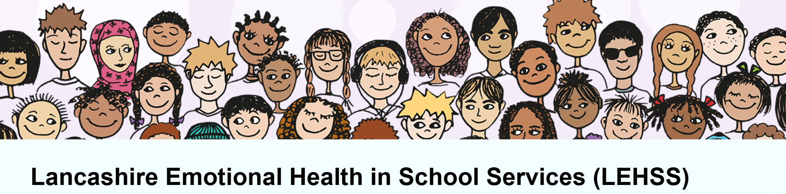

For any support and guidance -
SMHL contact in school – sharpr@brookfield56.lancs.sch.uk

